AN INDUSTRIAL TRAINING REPORT

**on**

**Time Series Analysis**

**Submitted by**

**Abhijeet Katiyar**

**161500012**

Department of Computer Engineering & Applications

**Institute of Engineering & Technology**



**GLA University**

**Mathura- 281406, INDIA**

**August, 2018**

Abstract

Certificate



Acknowledgement

**Table of Contents**

|  |  |
| --- | --- |
| Abstract | ii |
| Certificate | iii |
| Acknowledgments | iv |
| 1. **Introduction** (This chapter must describe introduction about your project) | **1** |
| 1.1 Overview | 1 |
| 1.2 Objective | 2 |
| 1. **Company Profile** | **7** |
| 2.1 Define | 7 |
| 2.2 ……………… ……………..………………………………… | 7 |
| 1. **Project / Training Design** | **16** |
| 3.1 ……………………….………………………… | 16 |
| 3.2 ……………………..…………………. | 17 |
| 1. **Project Implementation / Training Details** | **22** |
| 4.1 ………….……………………………………… | 22 |
| 4.2 ……………………..…………………. | 22 |
| 1. **Implementation and User Interface** | **27** |
| 5.1 ……………………………........ | 27 |
| 5.2 ….……………………………………………... | 27 |
| **References/Bibliography** | **28** |

**Introduction**

**1.1 Overview:** Data Mining is an approach where analytically designed to discover data (market related or business oriented) and in search of reliable patterns and/or logical relationships between

variables. Appropriate validation is used to find the patterns with the detected patterns among the data set. It is also called as data discovery or knowledge discovery. Data mining enhance the revenue and reduce the cost incurred for the exploration of data.

The general research associated with stock market is highly focusing on neither buy nor sell. But it fails to address the dimensionality and expectancy of a naive investor. The general trend towards stock market among the society is that it is highly risky for investment or not suitable for trade. The seasonal variance and steady flow of any index will help both for existing and naïve investor to understand and make a decision to invest in the stock market.

**1.2 Objective:** To solve these types of problems, the time series analysis will be the best tool for forecast and also to predict the trend. The trend chart will provide adequate guideline for the investor. Some time it may not address or forecast the variations or steady flow of the market. It may forecast only on particular season, but it is not adequate for long term decision making. The investors are very much interested to know the past trend or flow, seasonal growth, or variations of the stock. A general view or expectation is that it must give a holistic view of the stock market.

In this project I focused on real world problem in the stock market. The seasonal trend and flow is the highlight of the stock market. Eventually investors as well the stock broking company will also observe and capture the variations, constant growth of the index. This will aid new investor as well as existing people will make a strategic decision. It can be achieved by experience and the constant observations by the investors. In order to overcome the above said issues, I have used ARIMA algorithm in three steps,

Step 1: Model identification

Step 2: Model estimation

Step 3: Forecasting

**Project Implementation**

**3.1 Different Types Of Dataset:**

1. Cross-sectional data : Cross sectional data can obtained when there is multiple observations is taken from multiple individuals at same point time. In case of cross sectional data Time does not play any important role in analysis. Analysis of cross sectional data starts with visualization of basic statistical properties i.e. central tendency, dispersion, skewness, kurtosis.

2. Time series data : Timeseries data can obtained when there is multiple observations is taken form same source at different points of time. Time series data can be describe by trend, seasonality, stationarity, autocorrelation, and so on.

3. Panel data : Panel data is collection of multiple entities over multiple points in time. Panel data also known as longitudinal data.

**3.2 Introduction to dataset:** We have Nifty50 data from Apr-2010 to Mar-2018 <https://www.nseindia.com/products/content/equities/indices/historical_index_data.htm>

First we need to explore the data to check the presence of null values

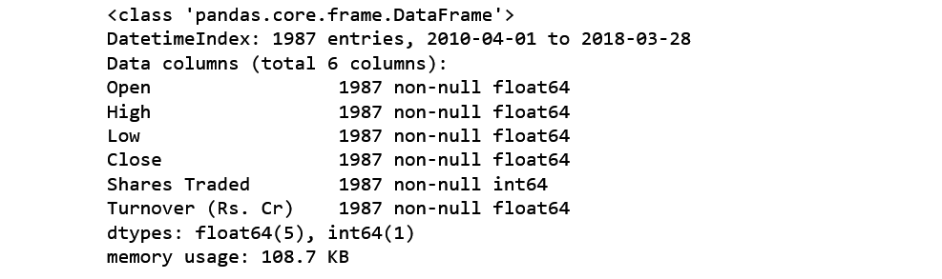

This is time series data with the frequency of business days.

Let’s understand the arguments one by one :

parse_dates: This specifies the column which contains the date-time information. As we say above, the column name is 'date'.

index_col : This argument tells pandas to use the ‘date’ column as index.

In this dataset we have DateTime series as index and 6 columns, 1987 entries for each. 5 of them are float and one is integer type also we don't have any Null values.

**3.3 Internal structure of Timeseries:** A time series is combination of trend, seasonal, cyclical, and irregular components.

General trend : A general trend can be identify by it's upward or downward movement in a long run. General trend can be seen with plotting the data, here we are using matplotlib library to plot Close prices.

import matplotlib.pyplot as plt

plt.plot(Nifty_data.Close)

plt.title('Nifty50 data for Close prices')

plt.show()

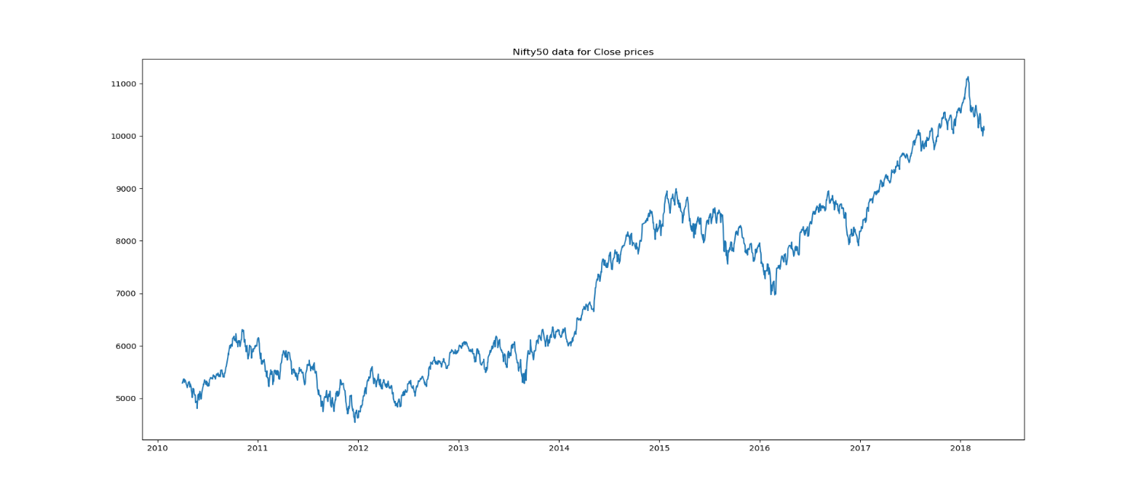

The graph is showing movement in upward direction, this is clear sign of presence of trend component.

General trend might not capable of being noticed during short run of time series.

**Seasonality:** If in time series data, there are patterns that repeat over known periods of time. For example, the consumption of ice-cream during summer is more than winter and hence an ice-cream dealer's sales would be higher in summer months. Mostly, presence of seasonality can be reveals by exploratory data analysis.

**Cyclical movements:** If there are movements observe after every few units of time, but they are not as frequent as seasonal components, are known as Cyclic components. cyclic components do not have fixed periods of variations.

**Unexpected variations:** These are sudden changes occurring in a time series which are unlikely to be repeated. They are components of a time series which cannot be explained by trends, seasonal or cyclic movements. These variations are sometimes called residual or random components. These variations, though accidental in nature, can cause a continual change in the trends, seasonal and cyclical oscillations during the forthcoming period.

The objective of time series analysis is to decompose timeseries into it's elements and develop mathematical models to predict future values.

**3.4 Stationary time series:** When a time series free from general trend and seasonality, it become stationary. Statistical properties like mean, variance, autocorrelation etc. of a stationary time series remains constant over time. It is important to gain stationarity before forecasting because most statistical forecasting methods are applicable on stationary time series.

we can check stationarity using the following:

**Plotting rolling statistics:** we can plot moving mean and moving variance and see if these terms are varying with time. let's plot the moving average for business week days, business month days, Quarterly and yearly. we have rolling() method in pyhon to calculate rolling statistics.

* Weekly

plt.plot(Nifty_data.Close,label='Close Prices',color='green')

plt.plot(Nifty_data['Close'].rolling(window=5).mean(),label='moving avg',color='orange')

plt.legend()

plt.title('Weekly rolling statistics')

plt.show()

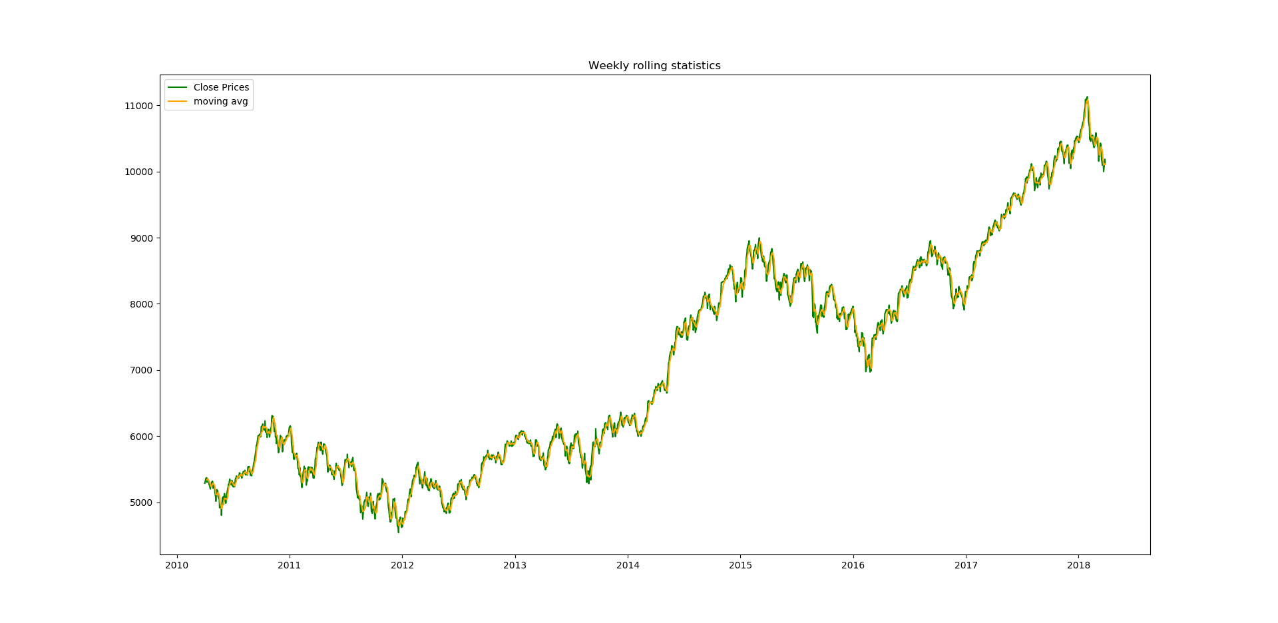

* Monthly

plt.plot(Nifty_data.Close,label='Close Prices',color='green')

plt.plot(Nifty_data['Close'].rolling(window=21).mean(),label='moving avg',color='orange')

plt.legend()

plt.title('Monthly rolling statistics')

plt.show()

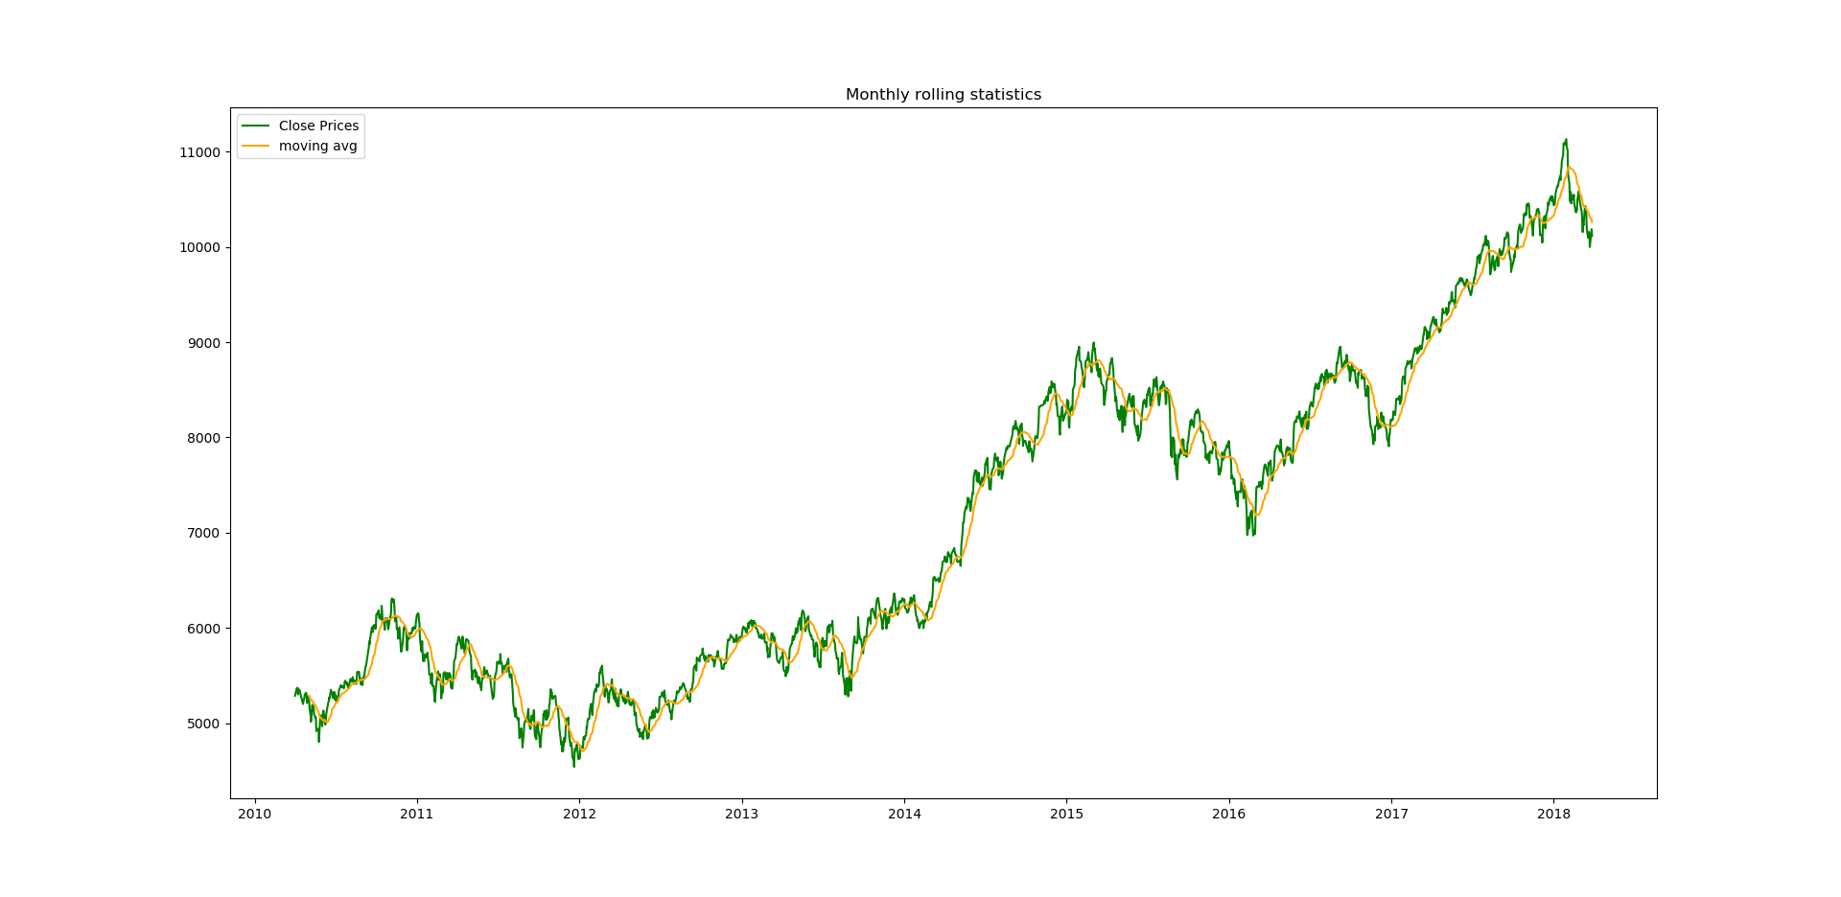

* Quarterly

plt.plot(Nifty_data.Close,label='Close Prices',color='green')

plt.plot(Nifty_data['Close'].rolling(window=63).mean(),label='moving avg',color='orange')

plt.legend()

plt.title('Quarterly rolling statistics')

plt.show()

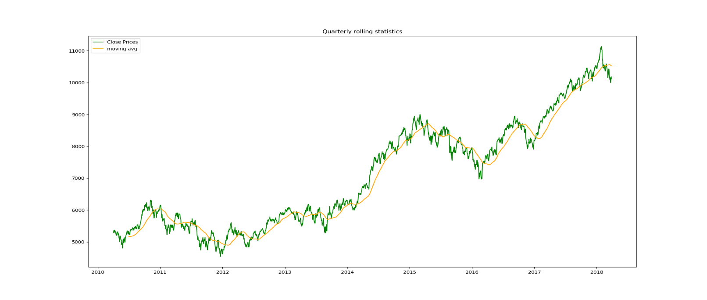

* Yearly

plt.plot(Nifty_data.Close,label='Close Prices',color='green')

plt.plot(Nifty_data['Close'].rolling(window=252).mean(),label='moving avg',color='orange')

plt.legend()

plt.title('Yearly rolling statistics')

plt.show()

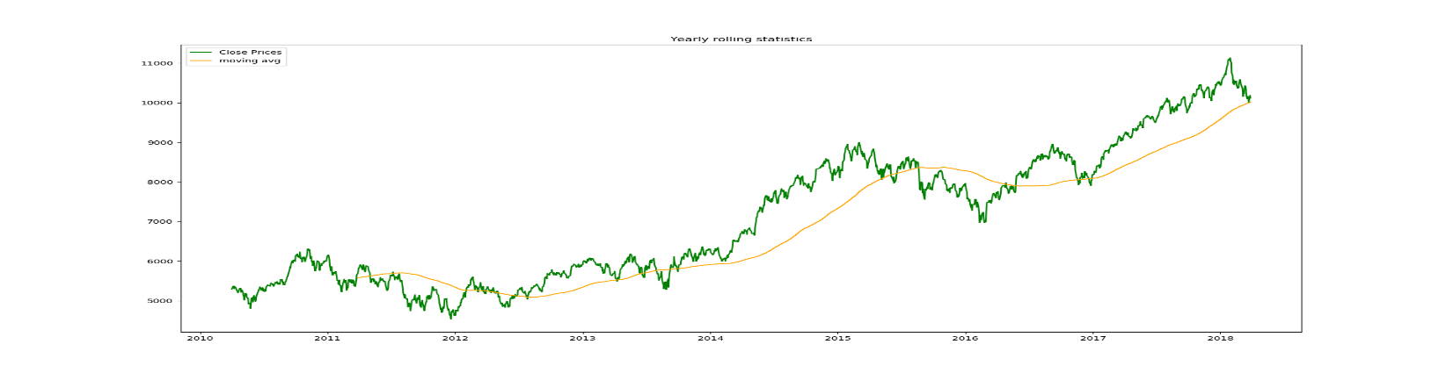

As we can see moving average is changing with time so, Time series is not stationary.

Augmented Dickey Fuller test: This is one of the unit root tests for checking stationarity. In this this test we check for null hypothesis, where H0 stats that time series is stationary whereas HA stats that time series is not Stationary. In python we have stattools.adfuller function to check the stationarity of time series.

from statsmodels.tsa.stattools import adfuller

stnry_test=adfuller(Nifty_data['Close'],autolag='AIC')

stnry_rslt = pd.Series(stnry_test[0:4], index=['Test Statistic','p-value','#Lags Used','Number of Observations Used'])

for key,value in stnry_test[4].items():

stnry_rslt['Critical Value (%s)'%key] = value

print(stnry_rslt)

if(stnry_test[1]>0.05):

print("Time Series is not stationary")

else:

print("Time series is stationary")

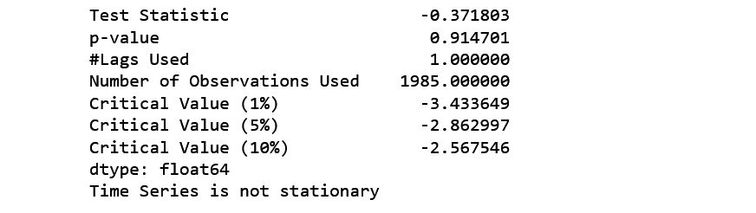

Note - if p-value is greater than 0.05 reject null hypothesis.

Here, p-value is 0.914701 which is greater than 0.05. Hence it is confirmed that our time series is not stationary.

To get stationary time series we need to remove trend and seasonality.

**3.5 Methods to detrending data:**

A time series can be detrended using following methods -

* Differencing
* Regression
* using functions

**Method to detrending timeseries using Differencing:** Differencing is the process of taking difference between successive occurrence of time series

Δxt = xt - xt-1.

Where, Δxt is stationary time series.

xt is original time series.

xt-1 is time series with lag 1.

In python we have shift() method to create a series with lag.

diff=Nifty_data['Close']-Nifty_data['Close'].shift(1)

There will be null values because of lag. It is important to remove null values otherwise adfuller test function will show an error i.e. "SVD did not converge"

diff.dropna(inplace=True)

plotting rolling statistics

plt.plot(diff,label='differenced timeseries',color='grey')

plt.plot(diff.rolling(window=252).mean(),label='Moving average',color='red')

plt.title('Yearly rolling statistics on diffrenced time series')

plt.axhline(y=0,color='green')

plt.legend()

plt.show()

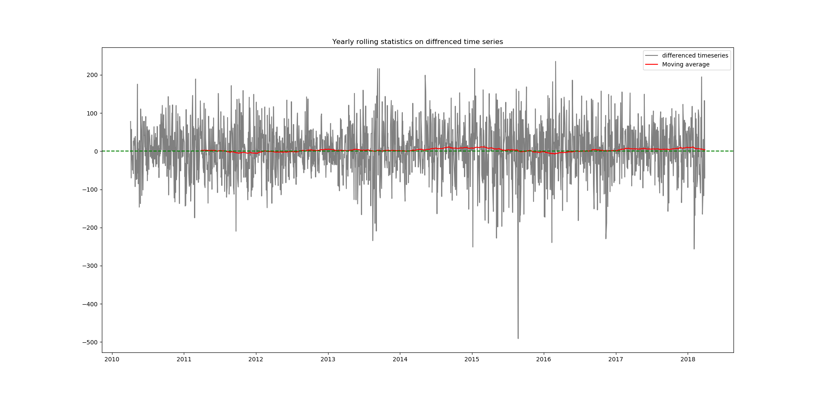

Now, the moving average is constant.

We can confirm the stationarity by apply Augmented DickeyFullerTest on `diff` time series –

stnry_test_diff=adfuller(diff,autolag='AIC')

stnry_rslt_diff = pd.Series(stnry_test_diff[0:4], index=['Test Statistic','p-value','#Lags Used','Number of Observations Used'])

for key,value in stnry_test[4].items():

stnry_rslt_diff['Critical Value (%s)'%key] = value

print(stnry_rslt_diff)

if(stnry_test_diff[1]>0.05):

print("Time Series is not stationary")

else:

print("Time series is stationary")

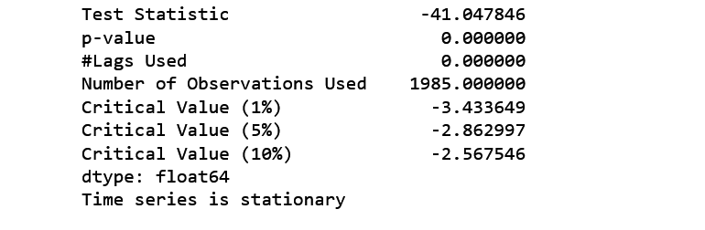

p-value is 0.000000 which is less than 0.05.

So, the time series is now stationary.

The method of differencing discussed above is first order differencing. After applying first order differencing It is possible that the time series may not become stationary then we have to perform second order differencing. To perform second order differencing, take difference another time.

x′t - x′t-1 = (xt - xt-1) - (xt-1 - xt-2) = xt - 2xt-1 - xt-2

This was the first method of making a time series stationary.

**Method to detrending timeseries using Regression:** Regression is another way to detrending timeseries data. Objective of choosing regression over differencing is to get trend line. Trend line can later be used as prediction of long run movement of time series.

Regression analysis is a form of predictive modeling technique which looks into the relationship between a target and predictor variables. Regression analysis is used for forecasting, time series modeling.

Here we fit a trend line to the training data, in such a manner that the distance between data points and trend line is minimum.

let’s perform linear regression, but first we have to separate training data and testing data.

# separating training and testing data

train = Nifty_data['Close'].iloc[:1750]

test = Nifty_data['Close'].iloc[1751:]

# building linear model

import numpy as np

from sklearn import linear_model

lm = linear_model.LinearRegression(normalize=True, fit_intercept=True)

Details of parameters:

Normaliz : This parameter is ignored when fit_intercept is set to False. If True, the regressors X will be normalized before regression. By default, this is set to False.

fit_intercep : whether to calculate the intercept for this model. If set to False, no intercept will be used in calculations. By default, this is set to True.

For more information about parameters you can see Linear Regression documentation.

Now we have to fit linear_model to Nifty_data timeseries

lm.fit(np.arange(np.array(len(train.index))).reshape((-1,1)), train)

Now let’s check the accuracy of fitted model

lm.score(np.arange(np.array(len(train.index))).reshape((-1,1)), train)



Now, we are going to plot close prices with trend line

plt.plot(Nifty_data['Close'],label='Original data')

plt.plot(pd.Series(lm.predict(np.arange(np.array(len(Nifty_data.index))).reshape((-1,1))),index=Nifty_data.index),label='Trend line')

plt.title('Close prices with trend line')

plt.legend()

plt.show()

Output will be –

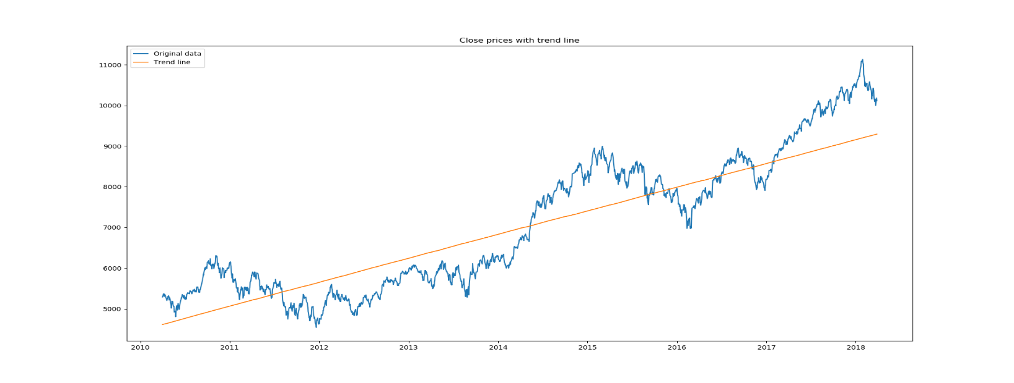

Now we are going to calculate residuals which will be used later in forecasting

Residuals=Nifty_data['Close']-lm.predict(np.arange(np.array(len(Nifty_data.index))).reshape((-1,1)))

plt.plot(pd.Series(Residuals,index=Nifty_data.index),label=Residuals)

plt.title('Residuals for Close prices')

plt.show()

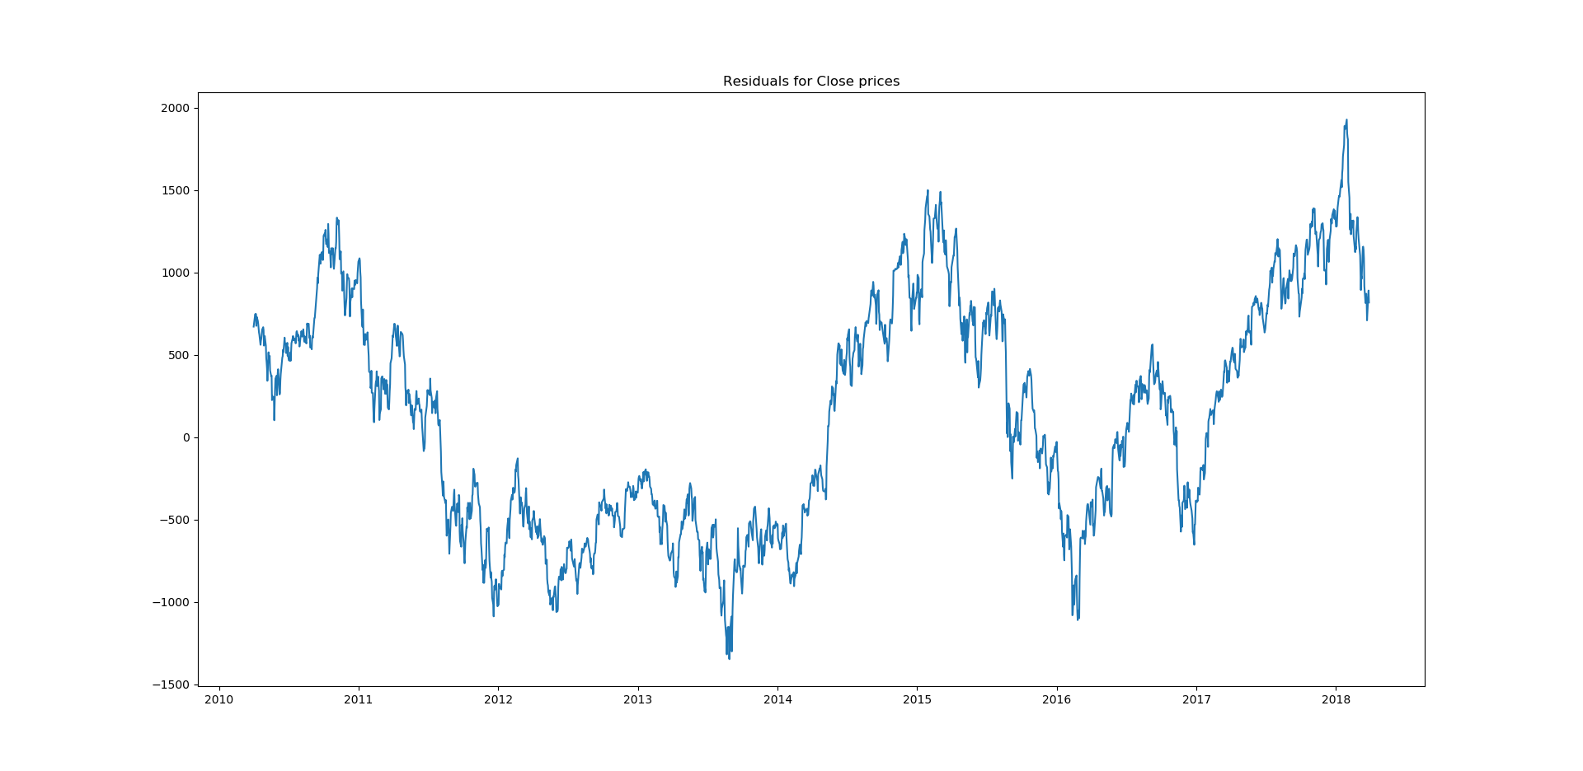

**Method to detrending timeseries using Functions:** There are many libraries in python which are specially made to perform Statistical operations, one of them is statsmodels.

from statsmodels.tsa import seasonal

decompose = seasonal.seasonal_decompose(Nifty_data['Close'],freq=252)

seasonal_decompose() method returns,

* Observed data (i.e. Close prices from Nifty_data dataset)
* Trend components
* Seasonal components
* Residuals

We can access Trend, seasonal components and Residuals by

decompose.trend, decompose.seasonal, decompose.resid respectively.

Note: Because we use 252 as frequency so we will have 252 null values in trend component and in residuals

decompose.trend.dropna(inplace=True)

decompose.resid.dropna(inplace=True)

Now, we are going to plot trend component.

decompose.trend.plot()

plt.title('Trend Component')

plt.show()

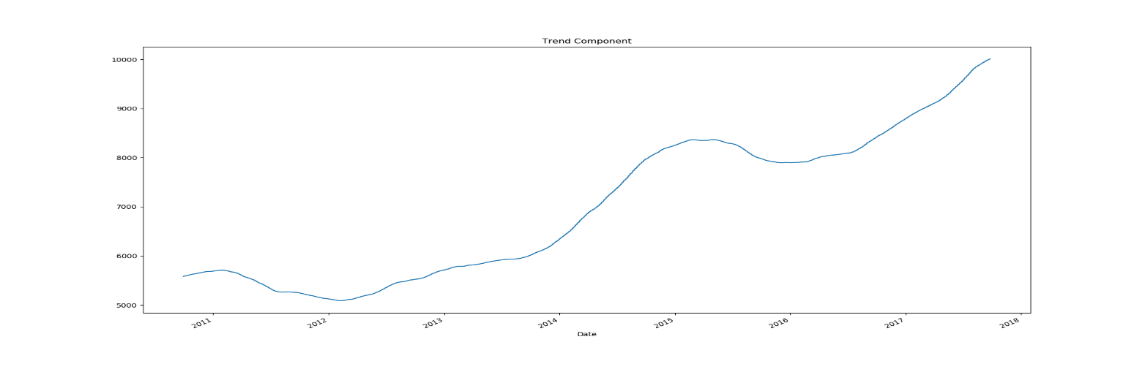

We detrended our time series now it's time to do work on seasonality.

**3.6 Estimating seasonality:** while removing trend by using differencing, seasonality was also removed so if we perform differencing method trend and seasonality both will removed while applying seasonal_decompose method we already get the seasonal component, so there is no need to perform any other operation to remove seasonality if we follow differencing or use statsmodels package. If we use regression then we don't get anything related to seasonality. So, we have to perform exploratory data analysis through following plots:

* Run sequence plot
* Seasonal subseries plot
* Multiple box plot

To remove Seasonality, simply take average of detrended data for specific season.

In these plots we will use Residuals –

Residuals=Nifty_data['Close']-lm.predict(np.arange(np.array(len(Nifty_data.index))).reshape((-1,1)))

**Run sequence plot:** A simple time series plot wit time on x-axis itself reveals following properties:

1. Movement in mean of series
2. Shifts in variance
3. presence of outliers

let’s visualize:

* Monthly

plt.plot(Residuals.rolling(window=21).mean(),label='residual mean')

plt.plot(Residuals.rolling(window=21).std(),label='residual std')

plt.plot(Residuals,label='Residuals')

plt.xlabel('year')

plt.ylabel('Residuals')

plt.title('Residuals,Monthly mean and Monthly Std ')

plt.legend()

plt.show()

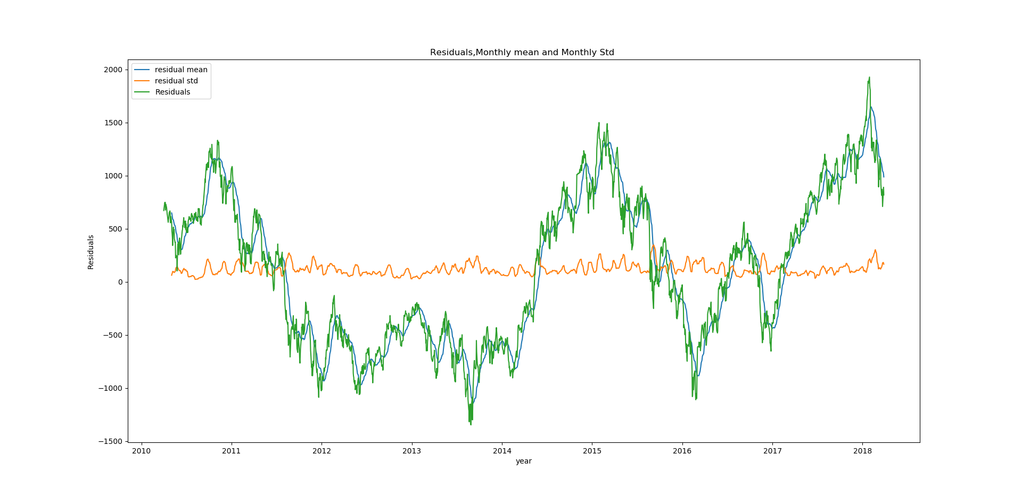

* Quarterly

plt.plot(Residuals.rolling(window=63).mean(),label='residual mean')

plt.plot(Residuals.rolling(window=63).std(),label='residual std')

plt.plot(Residuals,label='Residuals')

plt.xlabel('year')

plt.ylabel('Residuals')

plt.title('Residuals,Quarterly mean and Quarterly Std ')

plt.legend()

plt.show()

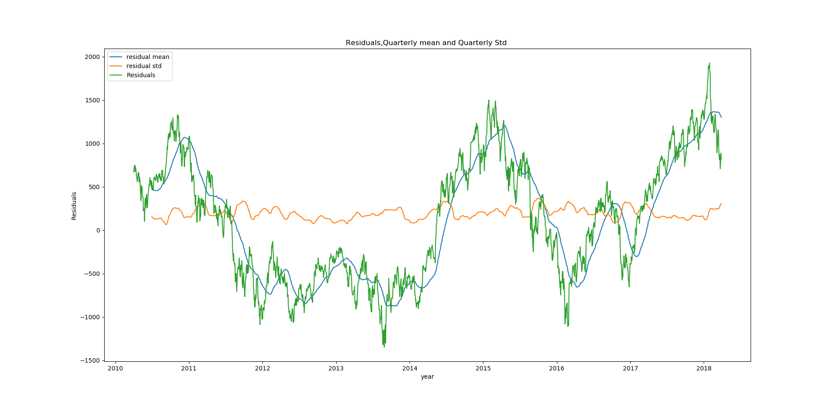

* Yearly.

plt.plot(Residuals.rolling(window=252).mean(),label='residual mean')

plt.plot(Residuals.rolling(window=252).std(),label='residual std')

plt.plot(Residuals,label='Residuals')

plt.xlabel('year')

plt.ylabel('Residuals')

plt.title('Residuals,Yearly mean and Yearly Std ')

plt.legend()

plt.show()

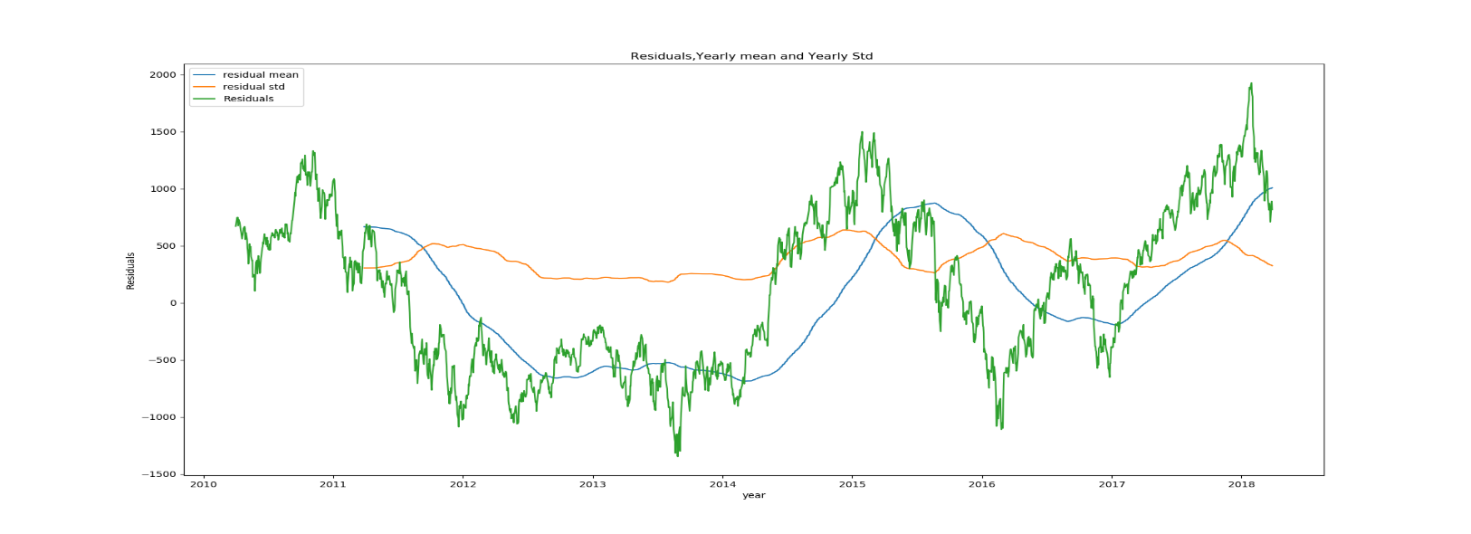

**Seasonal sub series plot:** We can identify seasonality by groping time periods like month, quarter or year. this method is only useful when time period of seasonality is known.

before plotting lets add columns for Residuals, months, quarter and years.

* Adding column "Residuals"

Nifty_data['Residuals']=Residuals

* Adding column "month"

Nifty_data['month']=Nifty_data.index.map(lambda x:x.month)

* Adding column "year"

Nifty_data['year']=Nifty_data.index.map(lambda x:x.year)

* Adding column "quarter"

month_quarter_map = {1: 'Q1', 2: 'Q1', 3: 'Q1',

4: 'Q2', 5: 'Q2', 6: 'Q2',

7: 'Q3', 8: 'Q3', 9: 'Q3',

10: 'Q4', 11: 'Q4', 12: 'Q4'

}

Nifty_data['quarter'] = Nifty_data['month'].map(lambda m: month_quarter_map.get(m))

Now we are going to calculate mean and standard deviation for residuals and making a new subseries. we already calculated residuals while detrending data using regression.

* Quarterly

# Creating new subseries

sub_series_quarterly = Nifty_data.groupby(by=['year', 'quarter'])['Residuals'].aggregate([np.mean, np.std])

sub_series_quarterly.columns = ['Quarterly Mean Close', 'Quarterly Standard Deviation Close']

#Create row indices of seasonal_sub_series_data using Year & Quarter

sub_series_quarterly.reset_index(inplace=True)

sub_series_quarterly.index = sub_series_quarterly['year'].astype(str) + '-' + sub_series_quarterly['quarter']

Let’s have a look to our sub series:

sub_series_quarterly.head()

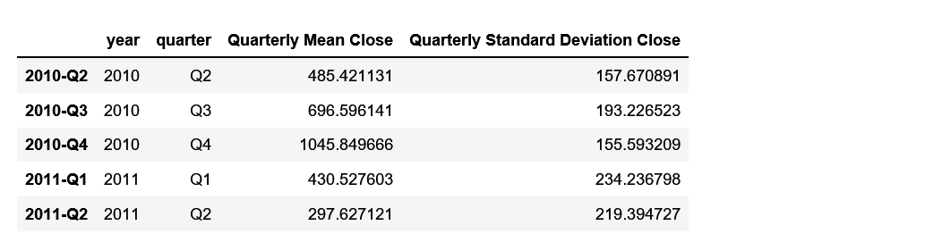

Now we are going to plot it –

sub_series_quarterly['Quarterly Mean Close'].plot(color='b')

plt.title('Quarterly Mean of Residuals')

plt.ylabel('Residuals')

plt.show()

sub_series_quarterly['Quarterly Mean Close'].plot()

plt.title('Quarterly standard Deviation of Residuals')

plt.show()

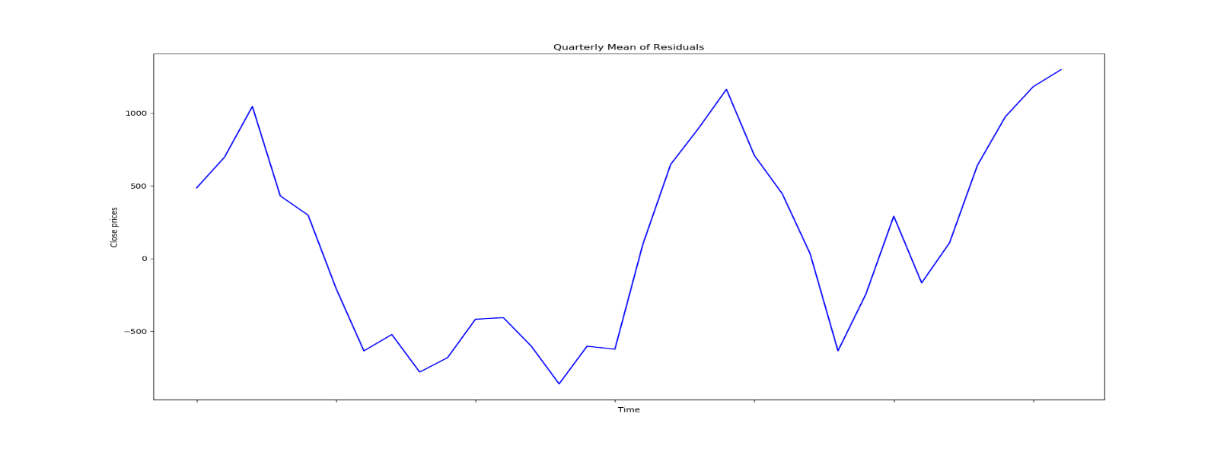

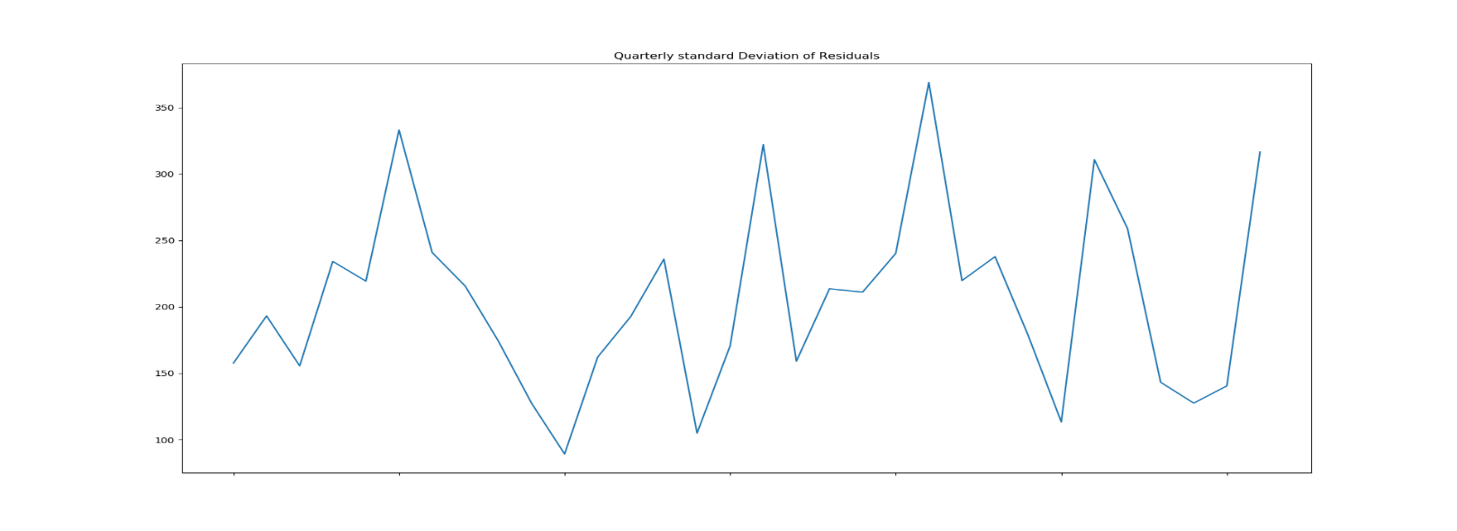

* Monthly

# Creating new subseries

sub_series_Monthly = Nifty_data.groupby(by=['month'])['Residuals'].aggregate([np.mean, np.std])

sub_series_Monthly.columns = ['monthly Mean', 'monthly Standard Deviation']

# plotting sub series

sub_series_Monthly['monthly Mean'].plot()

plt.title('Monthly mean of residuals')

plt.show()

sub_series_Monthly['monthly Standard Deviation'].plot()

plt.title('Monthly Standard Deviation of residuals')

plt.show()

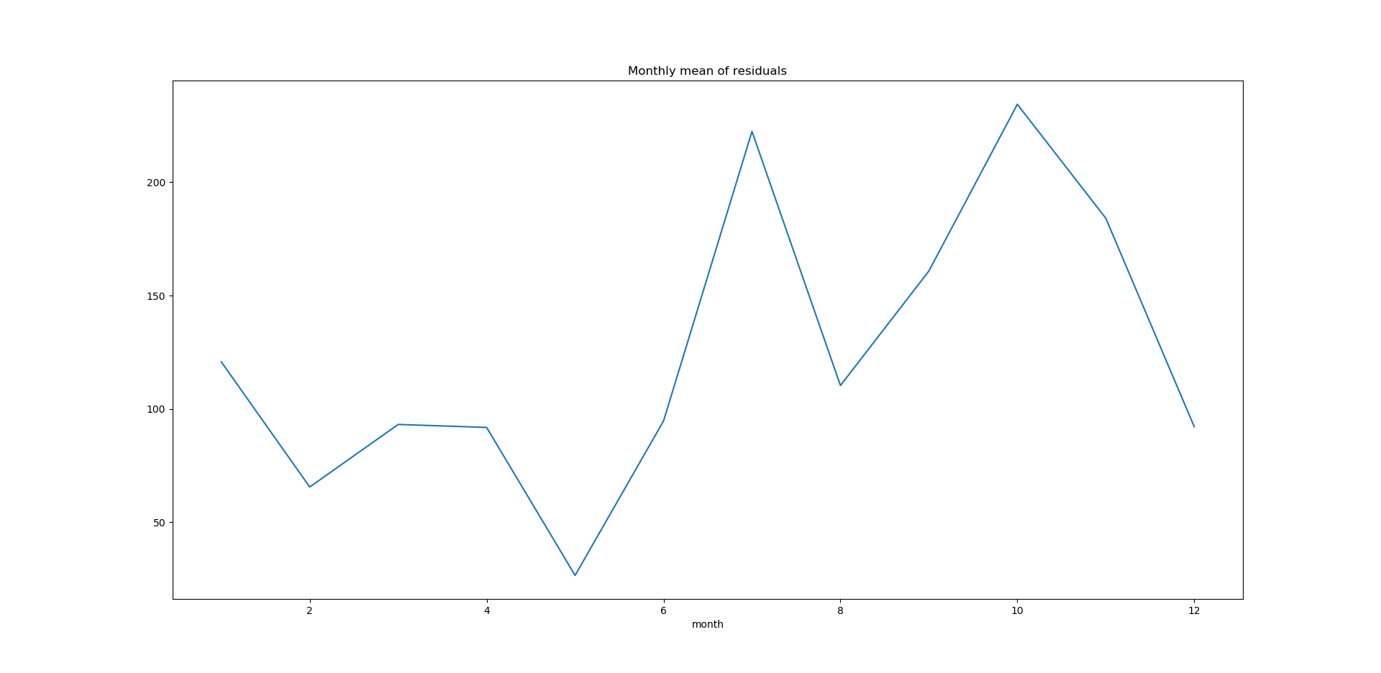

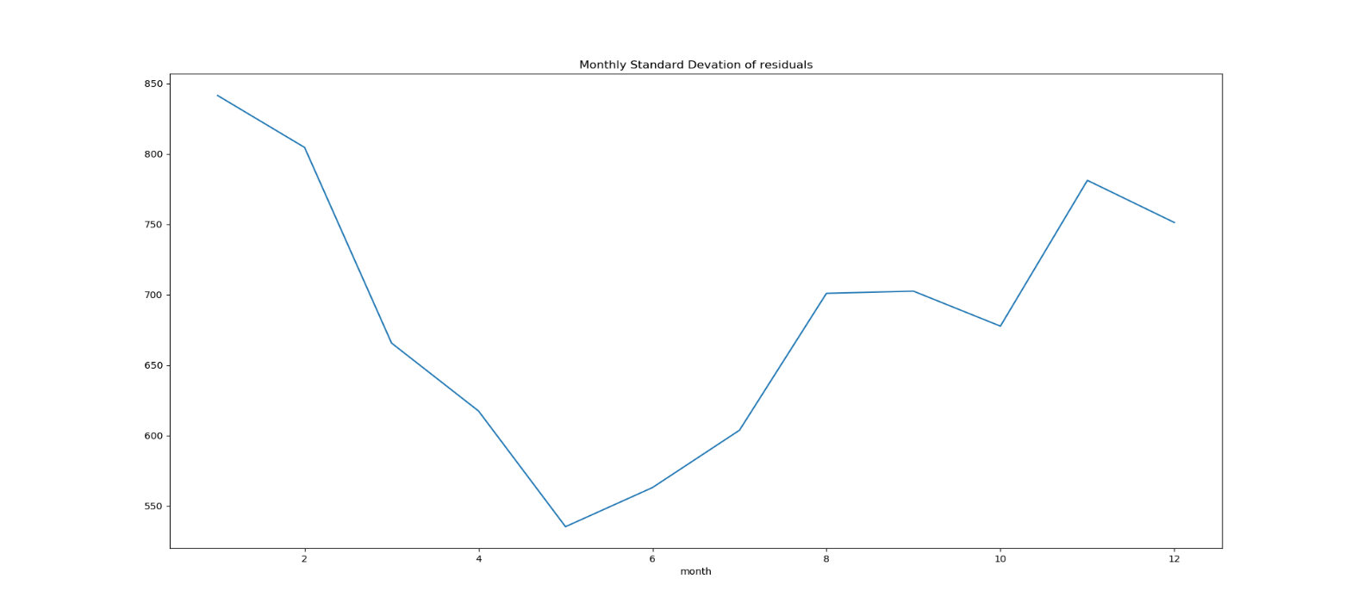

* Yearly

# Creating new subseries

sub_series_yearly = Nifty_data.groupby(by=['year'])['Residuals'].aggregate([np.mean, np.std])

sub_series_yearly.columns = ['yearly Mean', 'yearly Standard Deviation']

# plotting sub series

sub_series_yearly['yearly Mean'].plot()

plt.title('yearly mean of residuals')

plt.show()

sub_series_yearly['yearly Standard Deviation'].plot()

plt.title('Yearly Standard Devation of residuals')

plt.show()

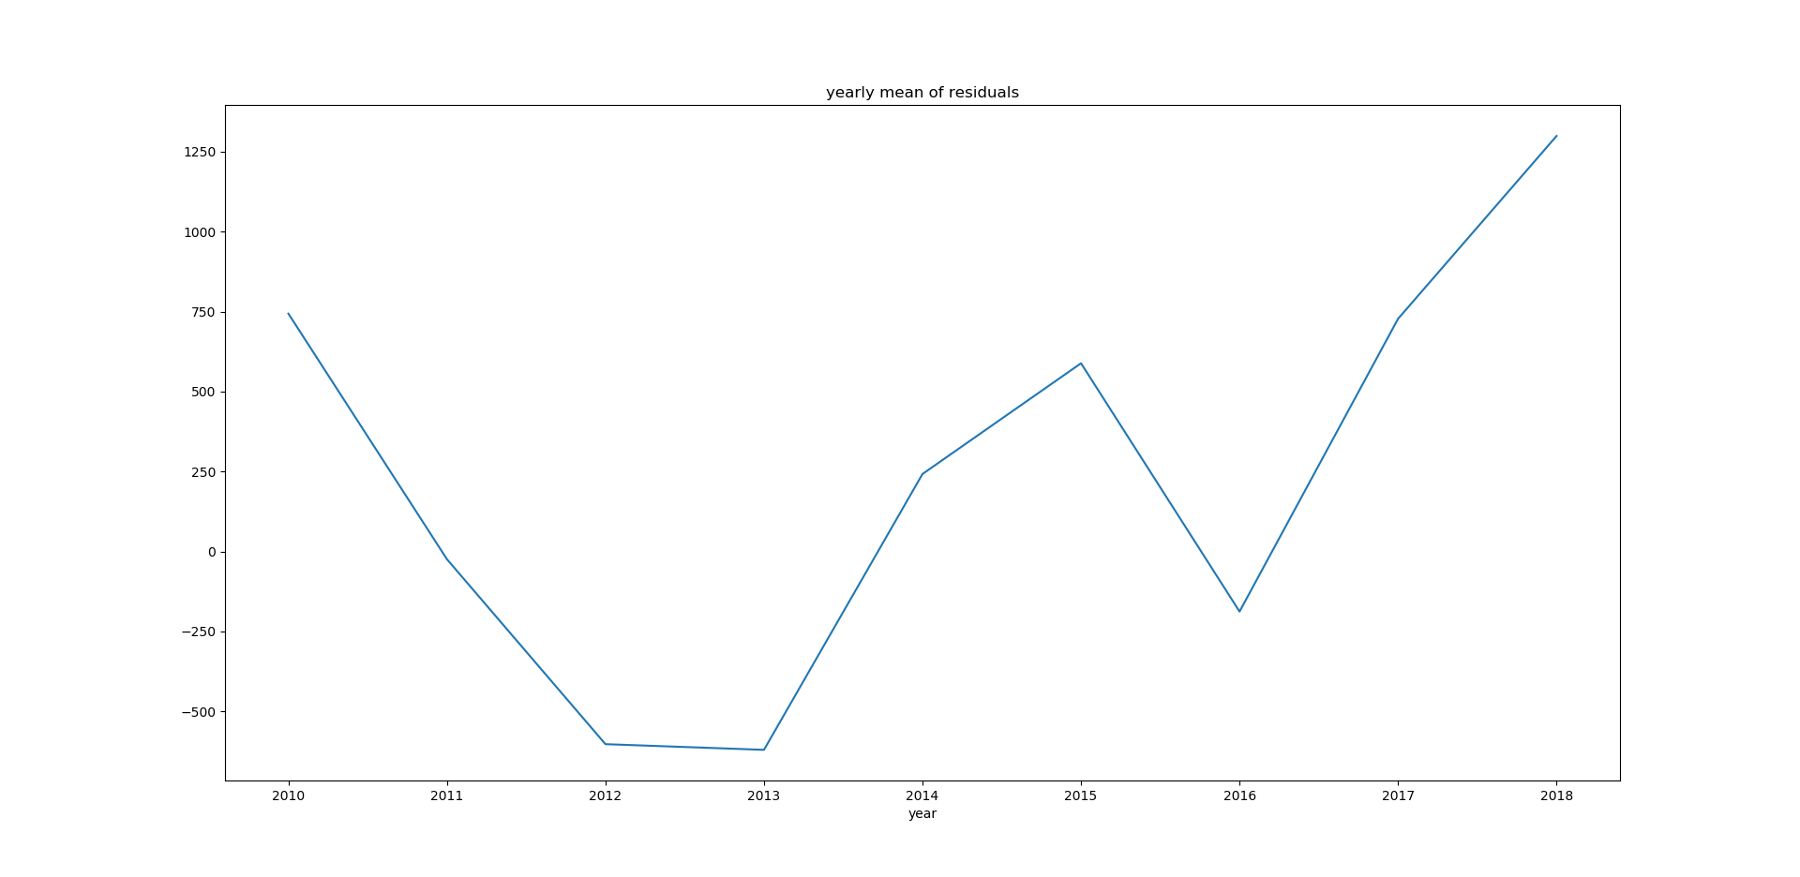

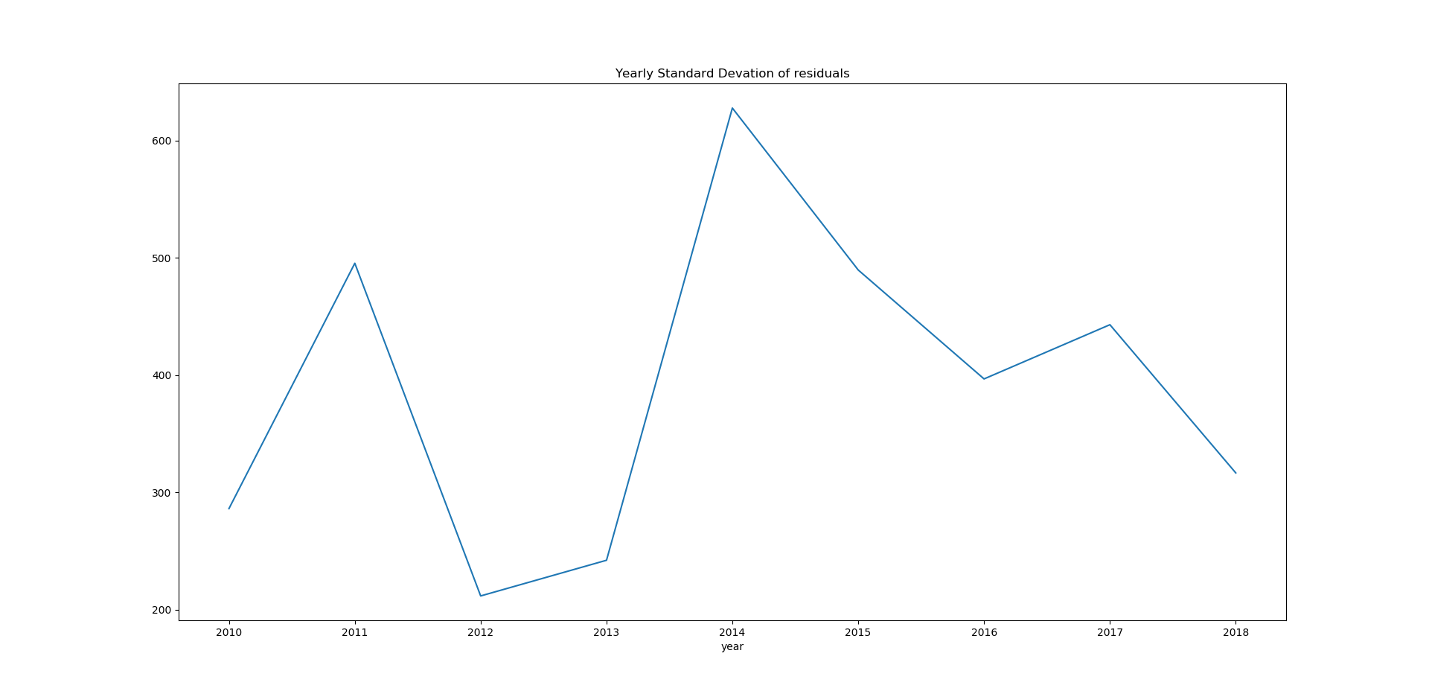

**Multiple box plots:** Multiple box plots are basically the boxplots of seasonal subseries plots. Box plots are more informative than any simple plot. Box plot revels information like mean, inter quartile range, minimum and maximum value and outliers, central tendency and dispersion.

For box plots we are going to use seaborn.

* Quarterly

# Multiple Boxplot(Quarterly)

import seaborn as sns

plt.figure(figsize=(5.5, 5.5))

g = sns.boxplot(data=Nifty_data[['Residuals','quarter']], y=Nifty_data['Residuals'], x=Nifty_data['quarter'])

g.set_title('Quarterly box plot of Residuals')

g.set_xlabel('Time')

g.set_ylabel('Residuals')

plt.show()

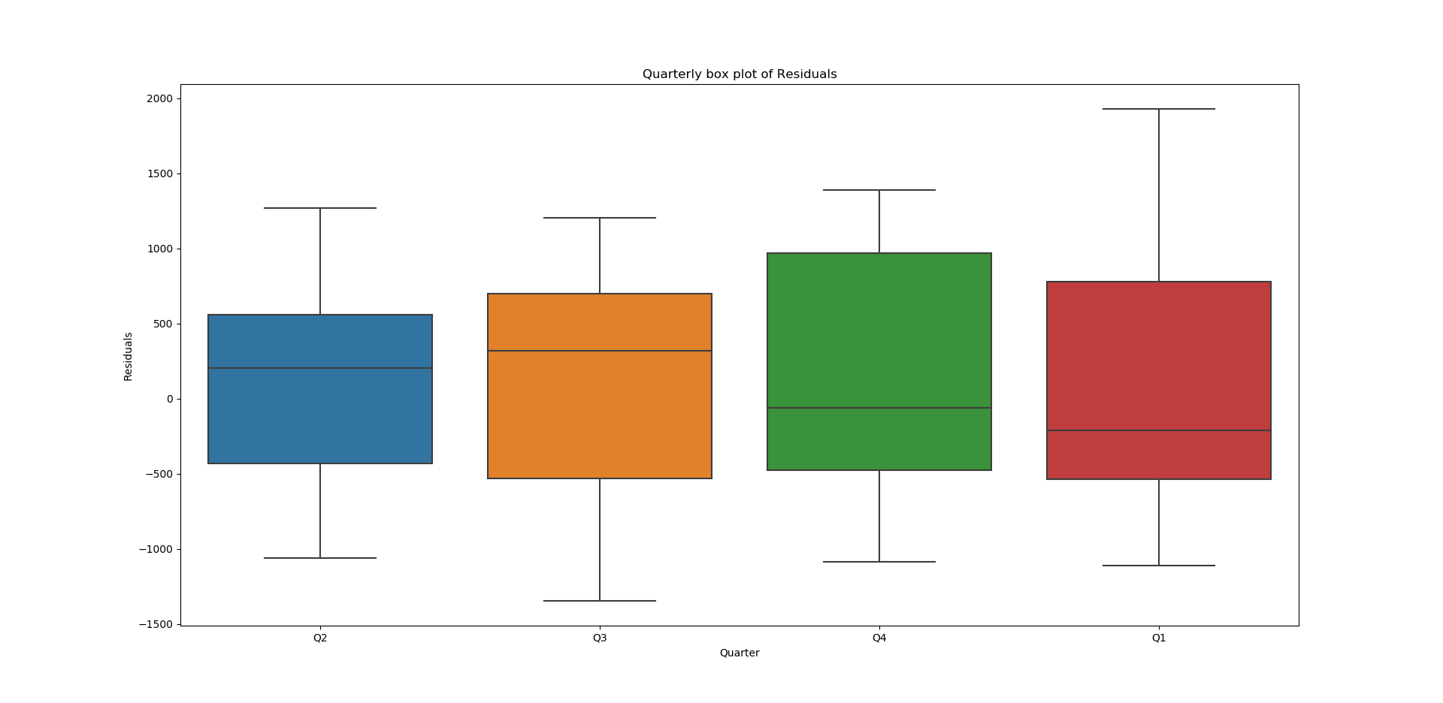

* Monthly

# Multiple Boxplot(Monthly)

import seaborn as sns

plt.figure(figsize=(5.5, 5.5))

g = sns.boxplot(data=Nifty_data[['Residuals','month']], y=Nifty_data['Residuals'], x=Nifty_data['month'])

g.set_title('Monthly box plot of Residuals')

g.set_xlabel('Time')

g.set_ylabel('Residuals')

plt.show()

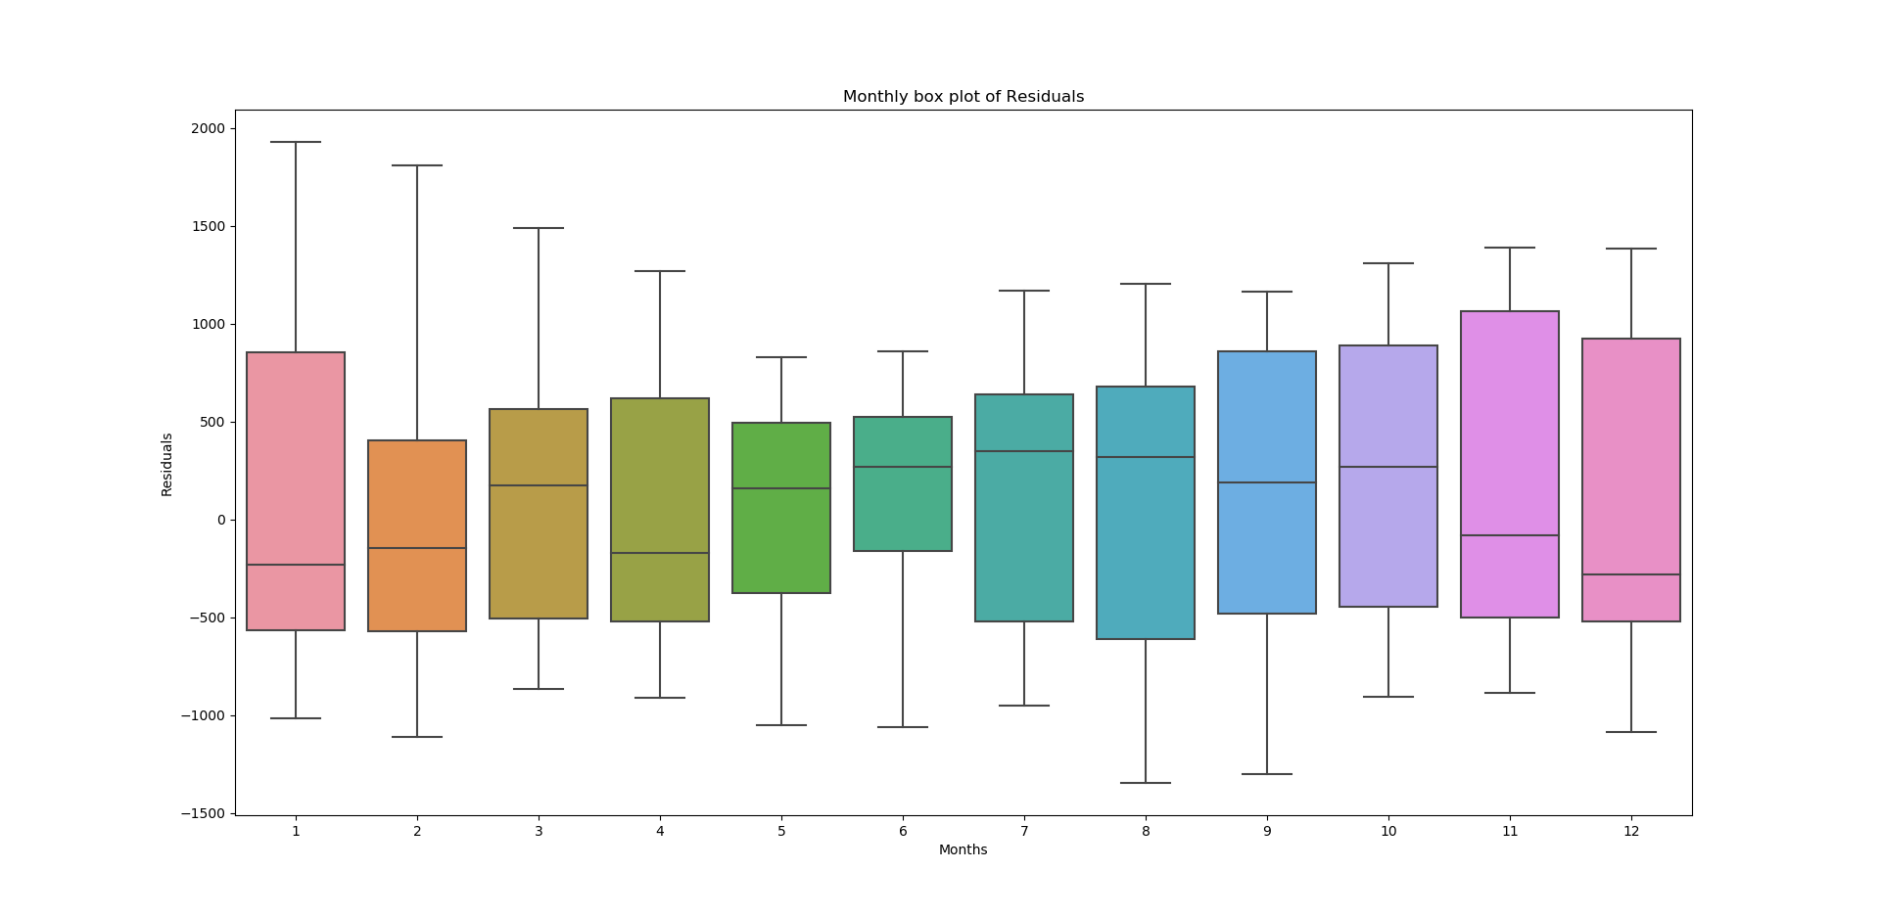

* Yearly

# Multiple Boxplot(Yearly)

import seaborn as sns

plt.figure(figsize=(5.5, 5.5))

g = sns.boxplot(data=Nifty_data[['Residuals','year']], y=Nifty_data['Residuals'], x=Nifty_data['year'])

g.set_title('Yearly box plot of Residuals')

g.set_xlabel('Time')

g.set_ylabel('Residuals')

plt.show()

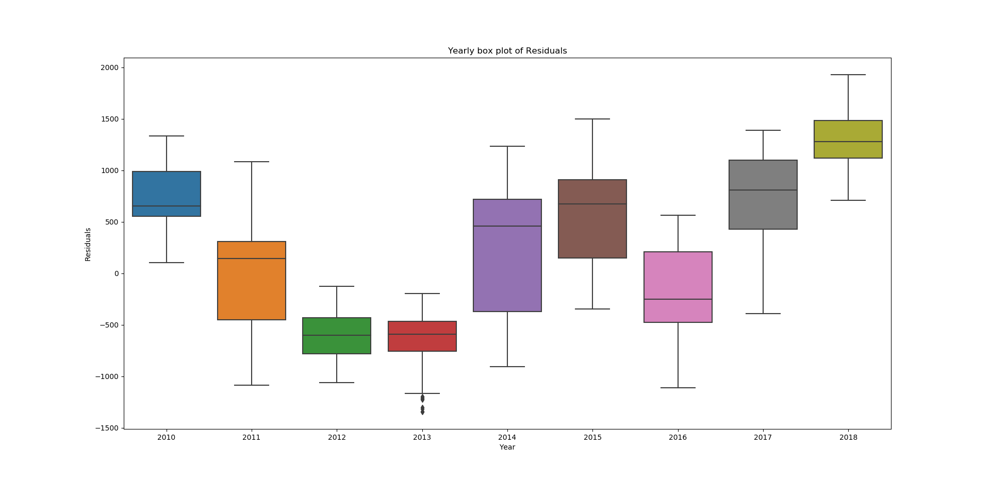

These are the methods to estimating seasonality.

**3.7 Forecasting:** For Time series forecasting ARIMA model is popular and widely used statistical method. ARIMA is an acronym of AutoRegressive Integrated Moving Average. It is generalization of AutoRegressive Moving Average and differencing.

**AR** (AutoRegression): This technique can be used on time series where output variable depends on its own previous values.

**I** (integrated) : This is order of differencing to make time series stationary.

**MA** (Moving Average) : A model that analyze data points by creating series of averages of subsets of data.

The ARIMA(p,d,q) represents the order of AR term, Differencing order and MA term respectively

To find the value of p and q we will plot autocorrelation and partial autocorrelation functions.

from statsmodels.tsa.stattools import acf, pacf

# ACF plot

lag_acf=acf(diff,nlags=20)

lag_pacf=pacf(diff,nlags=20,method='ols')

# plot ACF

plt.plot(lag_acf)

plt.axhline(y=0,linestyle='--',color='gray')

plt.axhline(y=-1.96/np.sqrt(len(diff)),linestyle='--',color='gray')

plt.axhline(y=1.96/np.sqrt(len(diff)),linestyle='--',color='gray')

plt.title('Autocorrelation Function')

plt.show()

# plot PACF

plt.plot(lag_pacf)

plt.axhline(y=0,linestyle='--',color='gray')

plt.axhline(y=-1.96/np.sqrt(len(diff)),linestyle='--',color='gray')

plt.axhline(y=1.96/np.sqrt(len(diff)),linestyle='--',color='gray')

plt.title('Partial Autocorrelation Function')

plt.show()

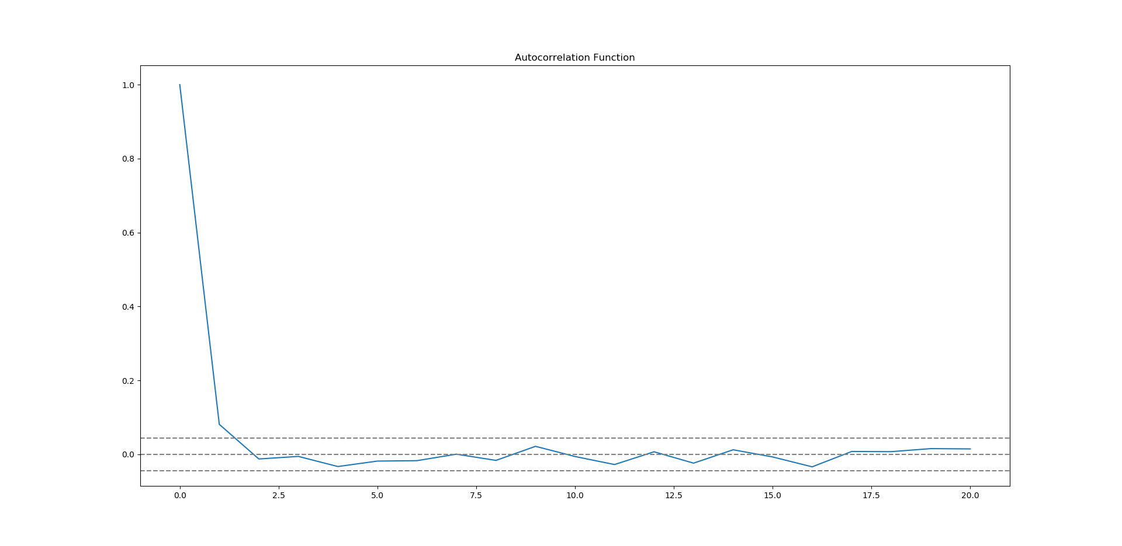

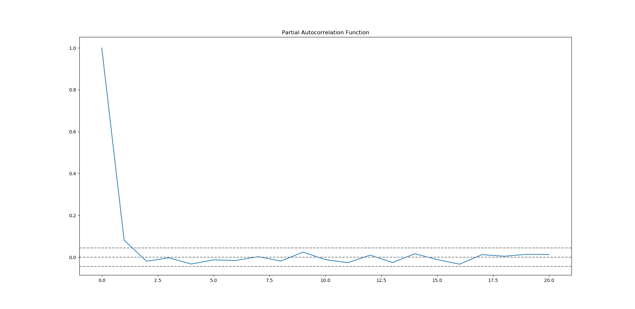

In these plots we draw the dotted line at y=0 and confidence intervals (dotted lines).

1. The value of p will be the lag value where the PACF chart crosses the upper confidence interval for the first time. In our plot it is 2.
2. The value of q will be the lag value where the ACF chart crosses the upper confidence interval for the first time. In our plot it is also 2.

Time series forecasting can be done in two ways :

1. We can calculate fitted values from model and take it back to original time series scale
2. Use .forecast() function on ARIMAresults, which performs one step forcast using the model.

**Forecasting without using .forecast() function:**

from statsmodels.tsa.arima_model import ARIMA

# seperating training and testing data

train=Nifty_data['Close'].iloc[:1750]

test=Nifty_data['Close'].iloc[1751:]

# Building ARIMA model

model = ARIMA(Nifty_data['Close'], order=(2, 1, 2))

results_ARIMA = model.fit()

# taking it back to original scale

predict_Arima=pd.Series(results_ARIMA.fittedvalues, copy=True)

predict_Arima.head()

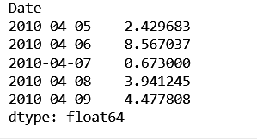

The first element of our original time series is lost because we took a lag by 1. to convert the differencing to log scale we will first determine the cumulative sum at index and then add it to the base number.

predict_Arima_cumsum=predict_Arima.cumsum()

predict_Arima_data=pd.Series(Nifty_data['Close'].iloc[0], index=Nifty_data.index)

predict_Arima_data=predict_Arima_data.add(predict_Arima_cumsum,fill_value=0)

predict_Arima_data.head()

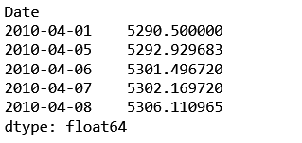

Now the series is on its original scale.

plt.plot(Nifty_data['Close'],label='Close prices')

plt.plot(predict_Arima_data,label='predicted values')

plt.legend()

plt.show()

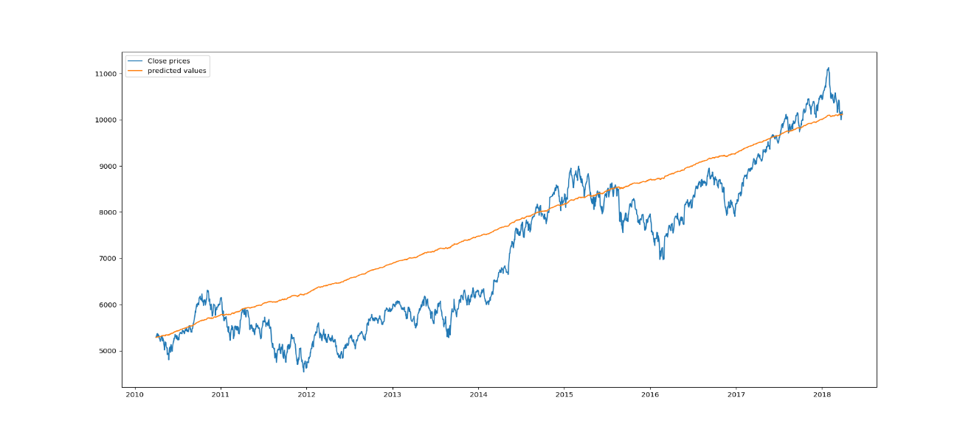

* Accuracy

import sklearn.metrics

sklearn.metrics.r2_score(Nifty_data['Close'],predict_Arima_data)

The accuracy is: 0.7398187397952602

**Forecasting using .forecast() function**

training_set = [x for x in train]

predictions = []

for i in range(len(test)):

model = ARIMA(training_set, order=(2,1,2))

model_fit = model.fit()

output = model_fit.forecast()

predictions.append(output[0])

obs = test[i]

training_set.append(obs)

print('predicted=%f, expected=%f' % (output[0], obs))

Sample of output is:

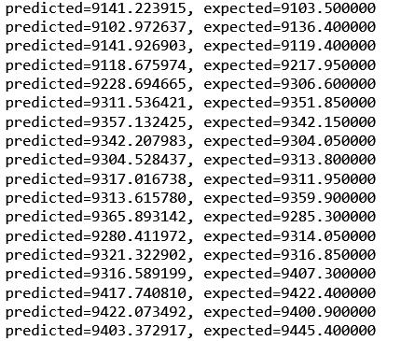

Plot of predicted values with test data:

pred=pd.Series(predictions,index=test.index)

plt.plot(test,label='Test data')

plt.plot(pred, color='red',label='Predicted values')

plt.title('Test data VS. Predicted values')

plt.legend()

plt.show()

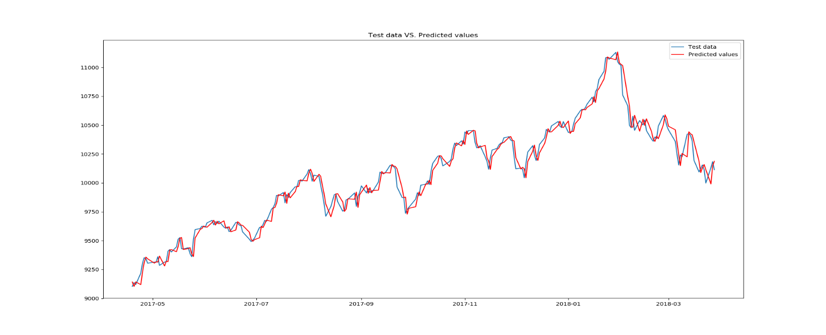

* Accuracy

sklearn.metrics.r2_score(test,pred)

The accuracy is: 0.9777090172770078